1. ***Monitor Your Estimated Charges Using CloudWatch***

***Step 1: Enable Billing Alerts***

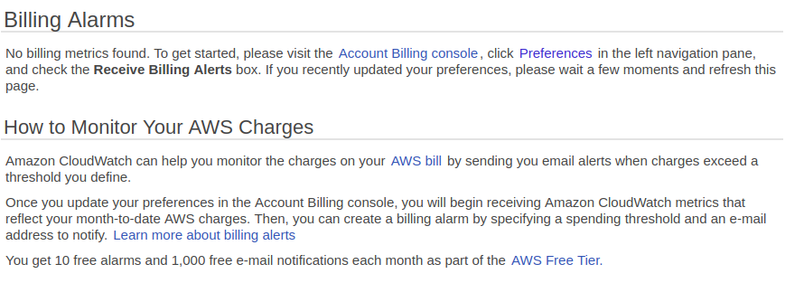

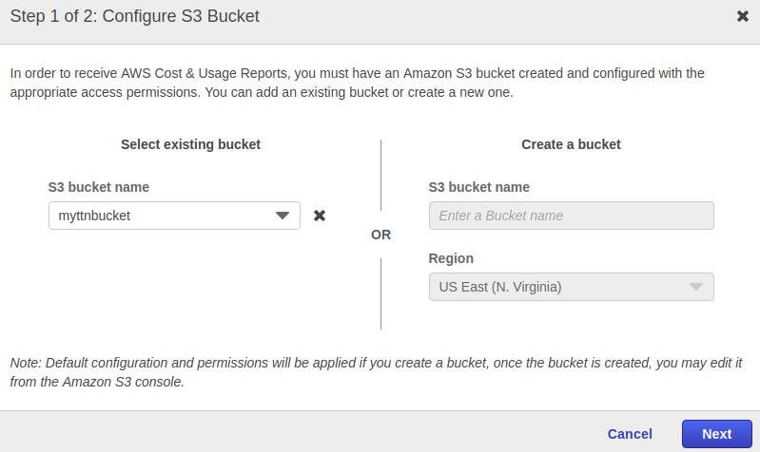

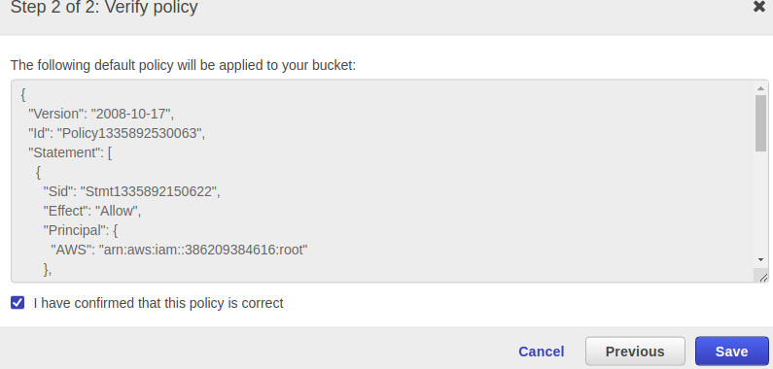

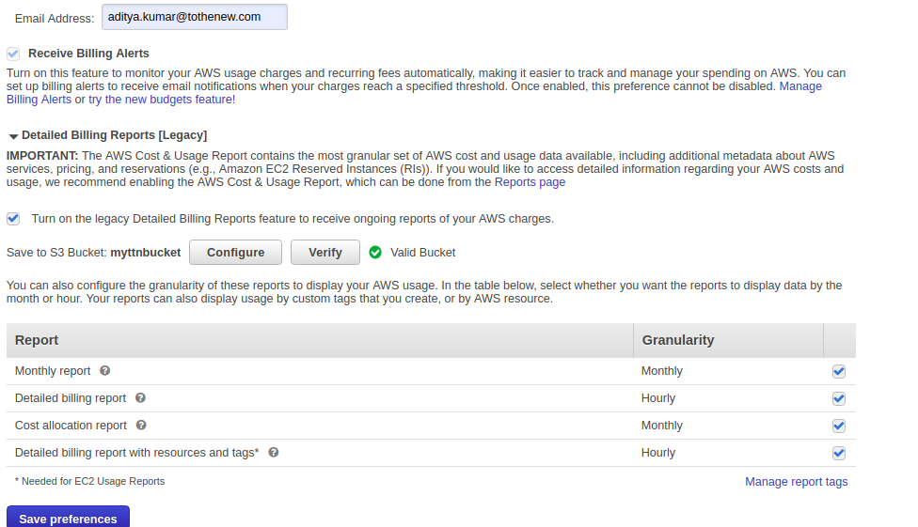

***Step 2: Create a Billing Alarm***

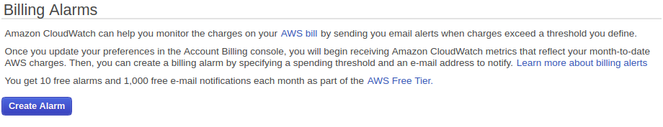

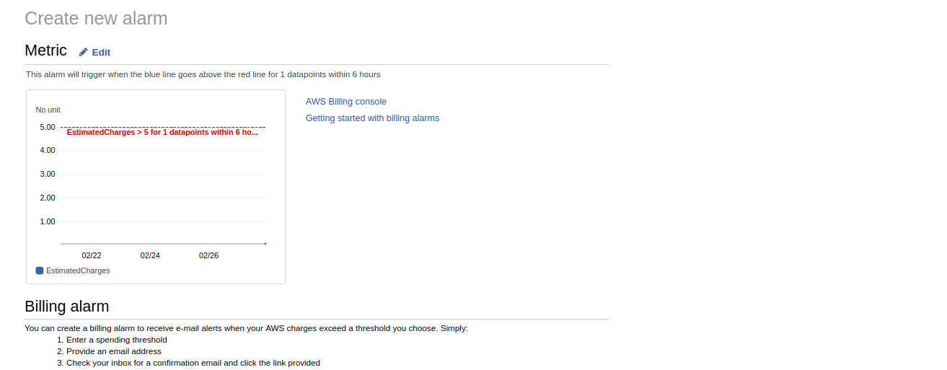

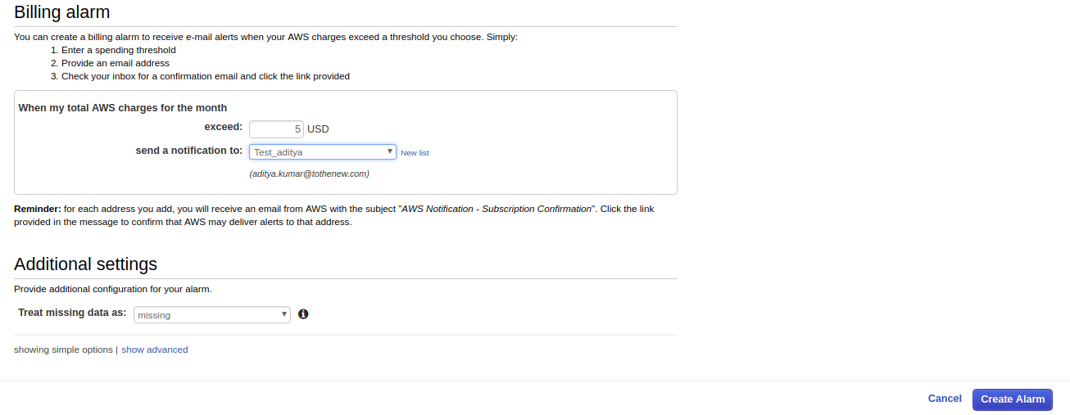

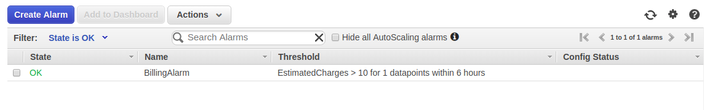

***Step 3: Check the Alarm Status***

*The alarm status is (OK) as seen in the above screenshot*

***Step 4: Create & Subscribe to SNS Topic***

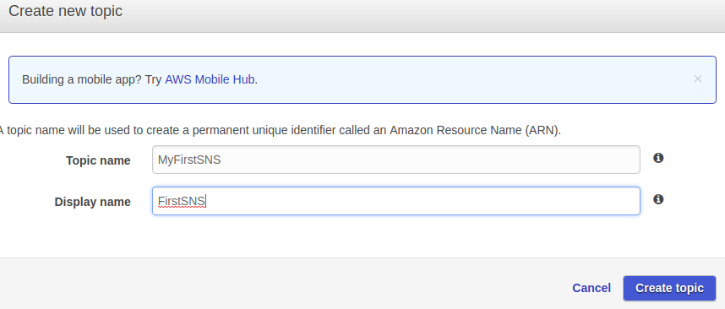

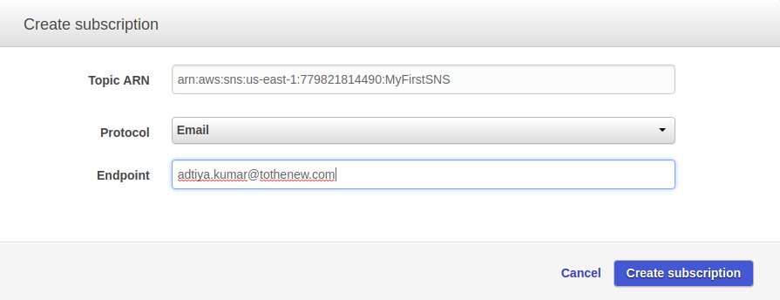

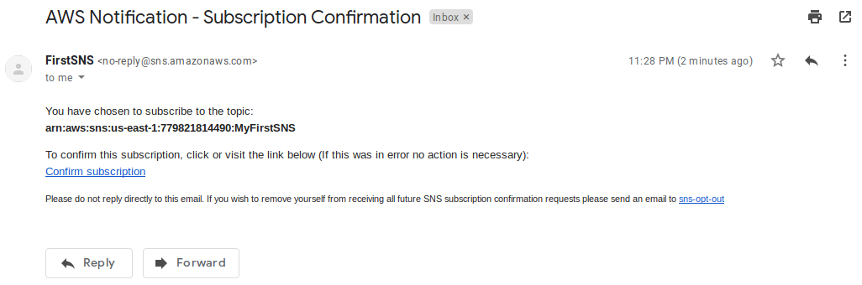

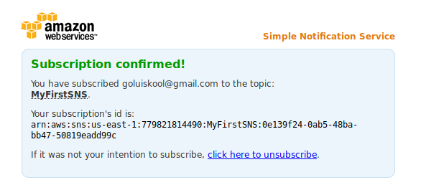

***Step 5: Send a notification all the stakeholder, if AWS resource pricing reaches the threshold value.***



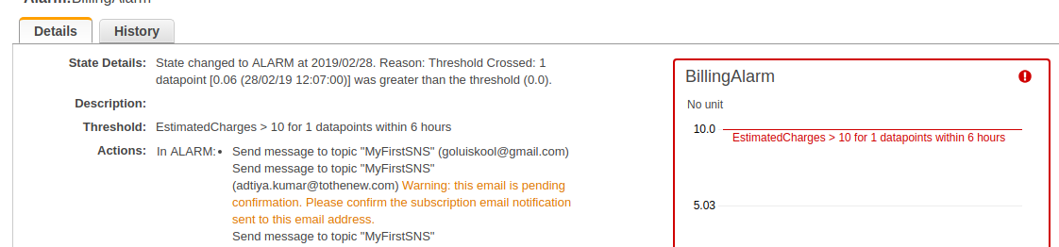

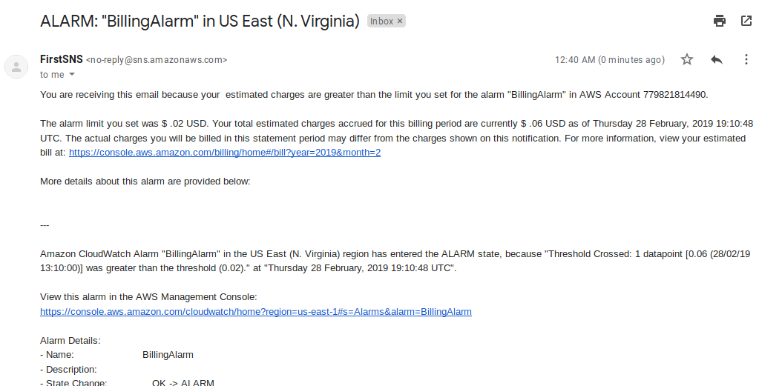

***2. Create a custom Memory metric in CloudWatch and set up alarm at 80 % which will autoscale the instance in the autoscaling group.***

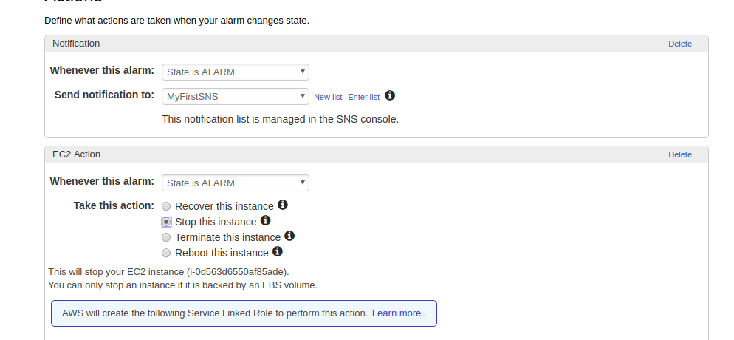

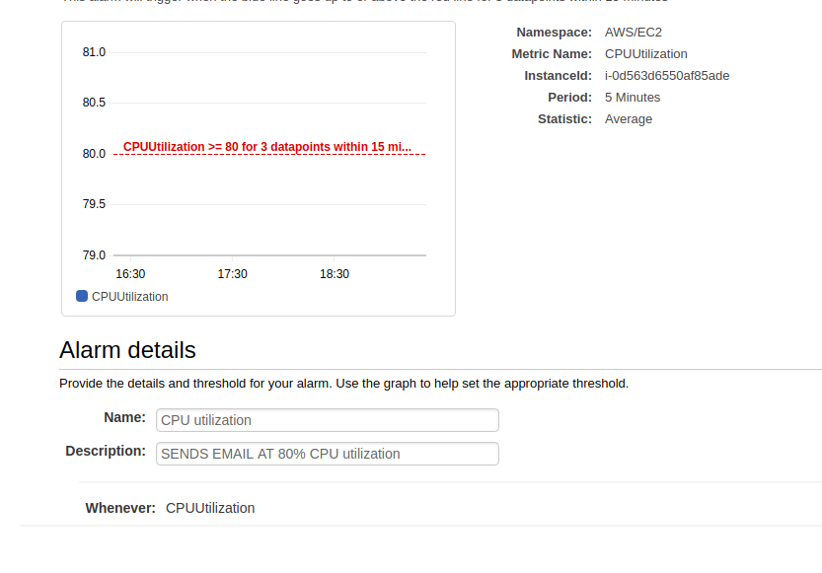

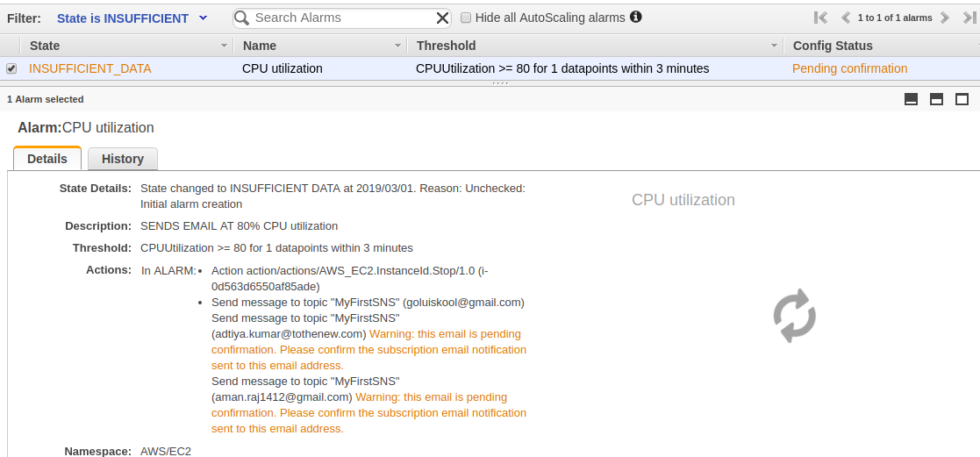

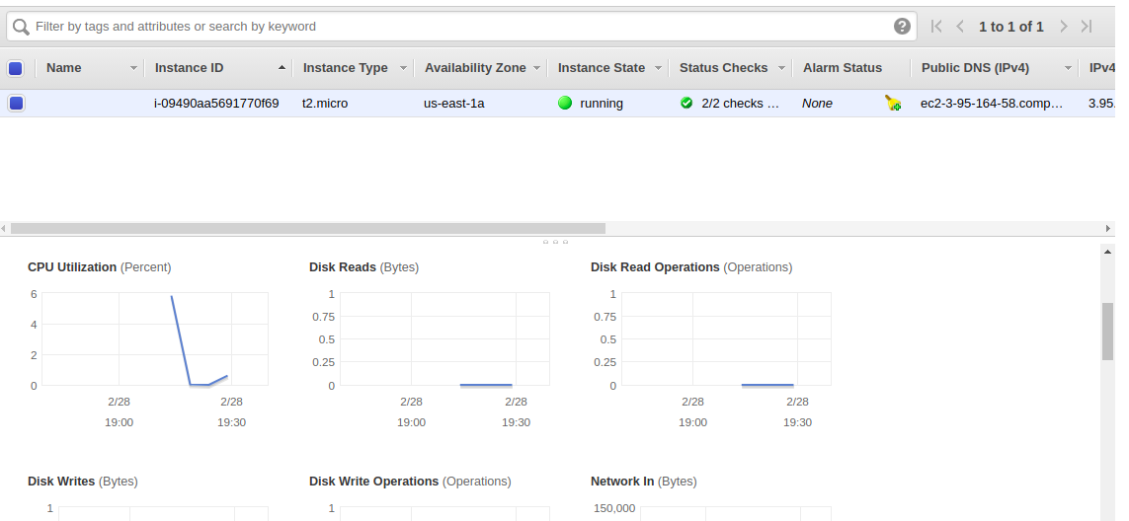

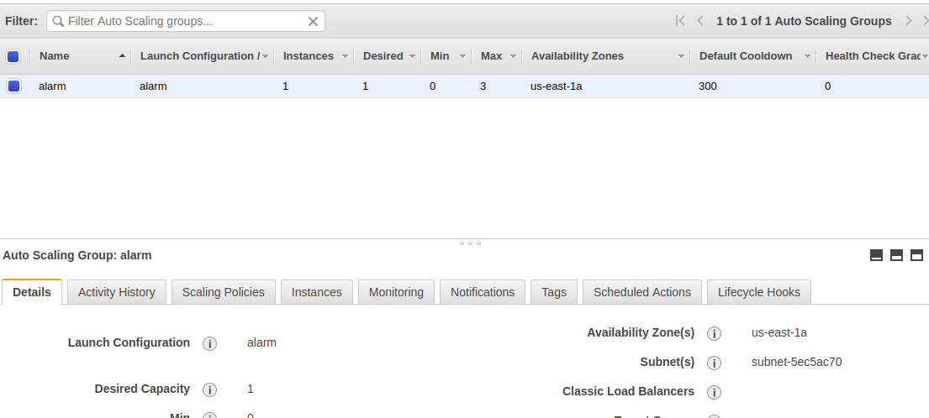

***3. Launch RDS aurora with one Read replica and Monitor RDS instance using CloudWatch and set up notification upon CPU utilization is above 80 %.***

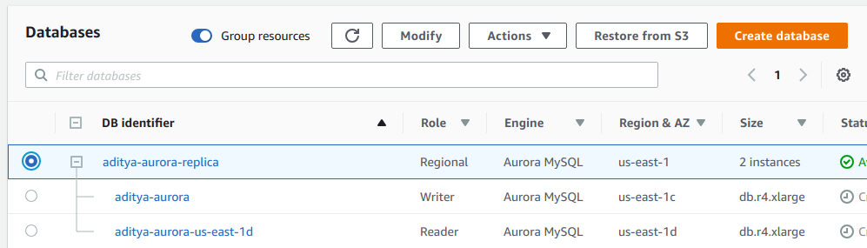

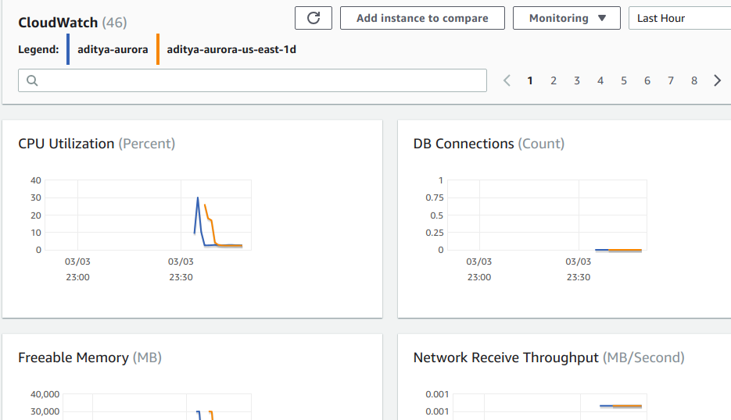

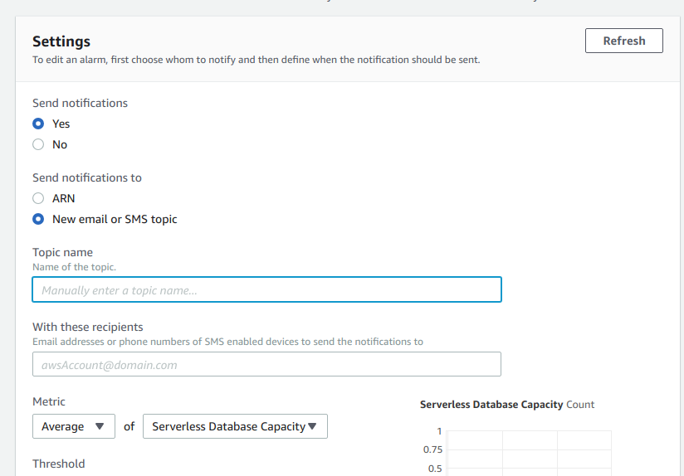

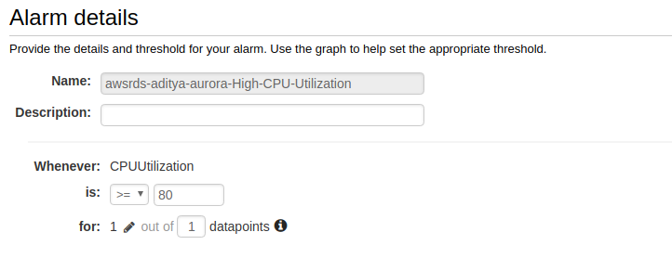

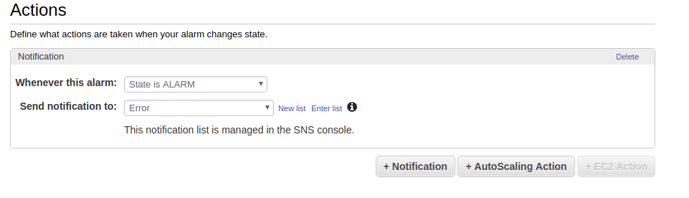

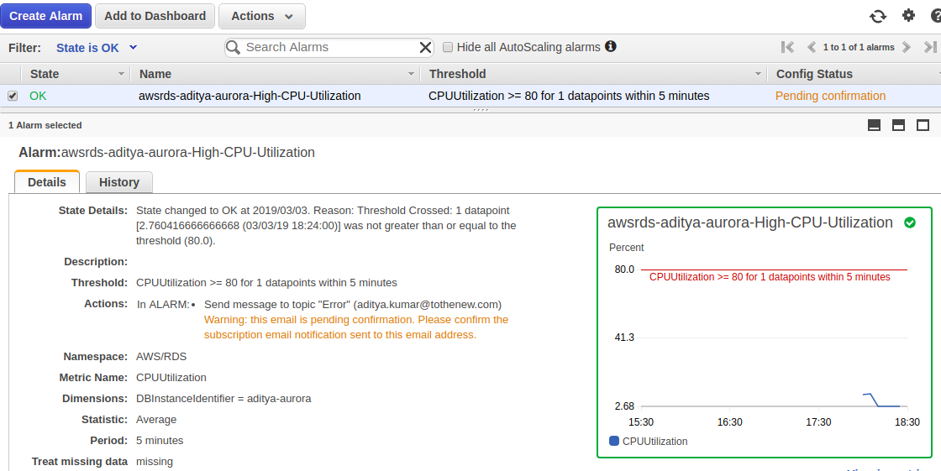

***4. Create SNS topic, subscribe to a topic, publish message, unsubscribe the message and delete the topic.***

